Criteria | Fragmented (<24 pts overall)  0-3 pts | Transitional (24-31 pts overall)  4-5 pts | Connected (32-35 pts overall)  6-7 pts | Nuanced (36-40 pts overall)  8 pts
Sorting molecular entities (concepts) | Grouping of entities are often scientifically non-normative and/or Mechanism-inappropriate. | Shows beginnings of boundary definition between mental categories. The grouping of most entities are scientifically normative and mechanism-appropriate. | Grouping of almost all entities is scientifically normative and mechanism-appropriate. | Groupings of all entities are scientifically normative and mechanism-appropriate. Boundaries between groupings are appropriate yet flexible.
Nature of connections (proposition/links) | Relies on associative terms or vague action terms or locations to build a mechanistic explanation. Entities or groups of entities are not connected or are linked but not described. | While vague and associative connections are still present, includes some causal or functional connections between molecular events. Very few missing or blank connections. | Molecular entities are temporally and spatially within mechanistic chains of molecular events. Use of vague, structural or categorizing connections is moderate. Associative connections are infrequent. | Connects entities with functional, mechanistic, causal, or action terms/phrases. Use of vague connections is infrequent and the use of, structural or categorizing connections used sparingly.
Connecting biological ideas (scientific reasoning) | Connection of ideas is frequently scientifically non-normative. Alternative connections are not plausible. | Heuristic reasoning is used to connect ideas. These ideas, though productive in some situations, serve to reinforce non-normative connections. | Scientifically normative connections are made between most ideas. Heuristic reasoning is less frequent. | All entities are connected by scientifically normative ideas.
Knowledge integration | Mechanisms are conflated, with little to no evidence of scientifically normative interrelatedness of groups. | Relationships between mechanisms are tenuous and may or may not be supported by scientifically normative arguments. | Describes a productively continuous chain of molecular events in which entities have corresponding temporal and spatial activities. Relationships between mechanistic groupings are supported by scientifically normative arguments. | Shows relationships between mechanistic groupings. Adds functional or causal connections to relevant biological phenomena and integrates several ideas to describe a nuanced overarching biological principle.
Communication | Information is not clear, very difficult to understand. | Information is presented and some understanding can be gained. | Information is presented clearly and allows for a good level of understanding. | Information is presented clearly and allows for a high level of understanding.

¹Southard K, Wince T, Meddleton S, and Bolger M.S. (2016) Features of knowledge building in Biology: Understanding undergraduate students’ ideas about molecular mechanisms. CBE – Life Sci Educ 15:1-16.
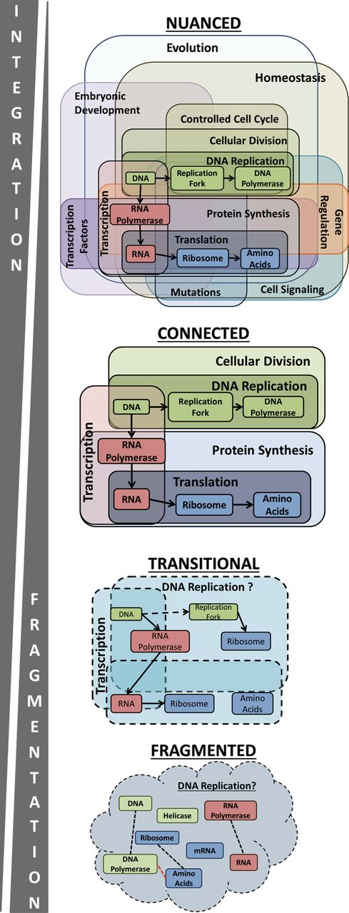
Illustration of different levels of knowledge integration¹.

Boundaries between mental categories are appropriate, yet flexible. Describes a productively continuous chain of molecular events in which entities have corresponding temporal and spatial activities. Adds functional or causal connections to relevant biological phenomena and integrates several ideas to describe a nuanced and overarching biological principle.

Sorts all entities into the appropriate categories. Ideas are connected to scientifically normative roles in the cell. Describes a productively continuous chain of molecular events.

Shows beginnings of boundary definition between mental categories for target mechanisms. Boundaries between mechanisms are tenuous. Mechanisms may or may not be appropriate to biological contexts. Occasional errors in the inclusion of mechanism-inappropriate entities.

Struggles to create productively continuous explanations. Though mechanistic entities are present, it is unclear which entities belong with which mechanism. Contains frequent disruptions in the chain of molecular events. Often names molecular entities associated with the mechanism while being unsure of their specific roles.

